WHAT WE THE PEOPLE CAN DO:

- ENGAGE your city council, county commissioners and other elected officials to demand your RIGHTS to safety, accountability, and transparency from the oil and gas industry. Public Officials need to listen to WE THE PEOPLE instead of powerful lobbyists

- URGE YOUR COMMUNITY to explore expanding their powers via Home Rule. EMINENT DOMAIN exists FOR the PUBLIC GOOD, not for corporate profit.

- SUPPORT THE YOUNGSTOWN RIGHTS-BASED BAN ON FRACKING which protects the rights of citizens to clean air, water, and land.

- CONTACT your state and federal representatives and DEMAND that they support the “Frac Act,” (Senate Bill: S.587, and House HR 1084) to remove exemptions to the Safe Drinking Water Act which will provide for public disclosure and regulation of chemicals used.

- JOIN THE PEOPLE OF YOUR COMMUNITY who are fighting back. In Syracuse Buffalo, and Pittsburgh, they have passed anti-fracking/disposal legislation. New Jersey and Maryland have also enforced bans or moratoriums.

Subscribe to national updates:
www.frackfreeamerica.org
/subscribe.html

ONLINE RESOURCES
buckeyeforestcouncil.org
celdf.org
cepr.net
chej.org
ecowatch.org
endocrinedisruption.com
frackcheckwv.net
FrackfreeAmerica.org
FrackfreeMahoning.blogspot.com
fractracker.org
GasLandthemovie.com
Neogap.org
NoFrackohio.com
OccupyYoungstown.org/
ohiodnr.com
OhioFracktion.com
ProPublica.org/series/fracking
shaletest.org
steingraber.com
taskohio.org
The Sky is Pink: http://vimeo.com/44367635
Vindy.com/news/fracking

WEB SEARCH THESE TOPICS:

NYTimes.com/DRILLING_DOWN_SERIES
“693 Ohio Wells failed inspections in 2011”
epa.gov (injection wells)
“Clyde, Ohio Cancer Cluster, EPA”
“Dimock, PA water pollution”
“Dish, TX air pollution study”
“Doctors Call for Fracking Moratorium”
“How gas wells leak”

“Impact of gas drilling on human and animal health - Cornell University”

“Irvin, PA gas well leak”
“N.Dakota oilfield wastewater radiation”
“OSU Study of the Economic Value of Shale”
“Pavillion, Wyoming Groundwater Pollution, EPA”
“Radon in Natural Gas from Marcellus Shale”
HYDRAULIC FRACTURING:
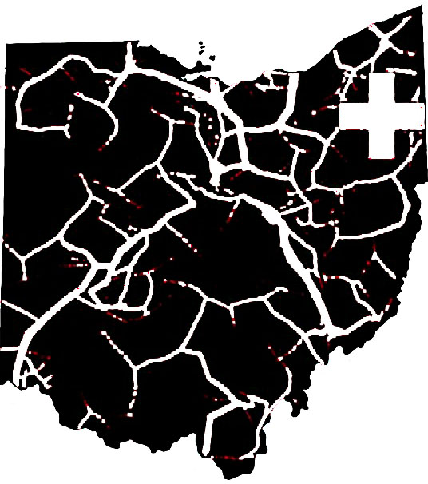Facts About High Volume Fracking and Hazardous Waste Injection Disposal Wells.

frackfreemahoning.blogspot.com
phone: 234-201-0402

“At what point does the preliminary evidence of harm become definitive evidence of harm? When someone says, ‘We were not aware of the dangers of these chemicals back then,’ who do they mean by ‘we?’”
- Sandra Steingraber
acclaimed ecologist,
author, and cancer survivor

Sign up for the TRUTH at:
frackfreemahoning@gmail.com
HYDRAULIC FRACTURING

What is “fracking?”
Hydraulic fracturing, or “fracking” is the means of extracting natural gas from deep shale formations.

Horizontal hydrofracking is a means of tapping shale deposits that were previously inaccessible by conventional drilling. The method differs from conventional gas extraction in that, after drilling vertically down to the shale, the drill bore is turned and tunneled horizontally through the shale. Millions of gallons of water, sand, and proprietary chemicals are then injected to fracture the shale.

The industry claims that hydro-fracking has been used for decades with no adverse affects. This is misleading. While fracking has been used for decades in the U.S., the scale today dwarfs previous practice. This new technique of horizontal fracturing has only been in use since the late 90s and is exempted from the Clean Air Act, Clean Water Act, RCRA, and the Safe Drinking Water Act.

The water combined with sand and proprietary chemicals (undisclosed trade secrets) injected into the well is referred to as brine. This is not pickle brine - this is hazardous waste. Since 2 - 8 million gallons of fresh water is needed for each well - if only 1% of toxic chemicals are added, that’s about 50,000 gallons of toxins per well, including carcinogens like benzene, toluene, ethyl benzene and xylene. Acid is used in fracking, and can degrade well-integrity over time. Additionally, naturally-occurring radioactive elements have been discovered in frack waste, yet the industry continues to refuse to list all of the chemicals used in fracking.

IT’S PRUDENT TO REMEMBER: 693 of Ohio’s wells failed inspection in 2011.

version 1/13 dml
INJECTION WELLS

Fracking waste is so toxic it must be disposed of in injection wells, a deep well into which fluids are injected for waste disposal. The ODNR (Ohio Dept of Natural Resources) determines where these wells are to be located. Local officials and citizens have little power to control this.

EARTHQUAKES

It is an injection well that is responsible for the Earthquake Cluster in Youngstown, Ohio. These wells can degrade over time, as happened in Clyde, Ohio. Injection wells are now responsible for a series of Earthquake Clusters from Lake Erie to central W. Virginia, including Ashtabula, Mahoning, and Washington Counties in Ohio, and Braxton County in West Virginia. One county in Oklahoma has over 180 injection wells, and quakes increased from an average of 50 per year to over 1000 in 2010. A cluster also occurred in Arkansas and Blackpool, UK, all linked to injection wells. Even the smallest of tremors can affect well-integrity because cement casing can crack. Also, larger quakes can open new fissures and channels for the already injected toxic waste to migrate in unpredictable paths.

WATER AND AIR POLLUTION

The EPA has completed a study of Pavillion, WY, that has concluded that there is a direct link between fracking and groundwater pollution. Dimock PA’s drinking water had become poisoned while the EPA decided whether to continue shipments of fresh water to the remaining citizens. A well in Coitsville, OH is a likely cause of the contamination of a drinking water source. Radon is detected in high concentrations at Marcellus shale well heads and can pass through gas lines into homes. A study of air pollution in the city of Dish, TX revealed that a chemical used in fracking had achieved “disaster potential.” Equipment such as compressors, fracking well engines, and oil/condensate tanks emit unacceptable levels of toxins into the air on a daily basis.

THE MYTH OF JOB CREATION

Two recent studies, including one by Ohio State University, have exposed how industry PR has over-inflated job creation. The actual numbers are 1/10th of industry claims. Many of these jobs are being outsourced (or a growing number of citizens of Ohio, PA, & W. Virginia are renewing their license plates in Texas and Oklahoma.) Fracking jobs are unsustainable, and offer no long-term stability. Oil and gas industry internal emails and documents reveal great skepticism over the so-called “Shale Gas Boom.” Also, if earthquakes continue to be a problem, businesses will not be inclined to expand into an earthquake zone such as Northeast Ohio, which doesn’t require the accompanying building codes to protect them.

THE DANGERS TO COMMUNITIES

There are many cases of emergencies at Ohio and Pennsylvania well sites, including explosions/fires/contamination, and even the deaths of workers. Local responders, who are not provided knowledge of industry materials, face greater risk. The increase in truck traffic is causing a tremendous burden on local communities who must deal with the increased noise and stress on infrastructure, not to mention the dangers of hazardous waste spills.

OHIO ENERGY LAW: 315

This law passed in May, 2012, has safety and disclosure rules written by the Gas Industry. It ensures that the gas company can hide the chemicals they use in the fracking process as “trade secrets,” and disclosure is not required until 60 days after drilling, which is too late for communities to test what was in their water before drilling. There is a minor tax on individual wells, but it is “offset” by new tax breaks on property and other “giveaways”, that is, the gas company pays less in Ohio taxes than in any other state in the country. There is no public notice when a well is set up, nor is there a right to appeal drill sites, pipelines or compressor stations. Ecowatch.org

